MONOPOLISTIC COMPETITION AND MONOPOLY

by Student’s name

Course code+name
Professor’s name
University name
City, State
Date of submission

Monopolistic Competition and Monopoly
A monopoly can be referred to as a single provider of services or goods in a particular locality. In this type of business operation availability of a substitute is very rare…….
……….This aspect propels the monopolistic competition to a real perfect competition and ends the firms’ economic gains. Monopolistic competition can fall into natural monopoly in areas where consumers’ rationality is very low. This occurs with total disregard to whether there is a governmental intervention or not (Davies et al. 2005).
Characteristics of Monopolistic Competition
- There are many consumers and many producers granting total control of the market to no particular business.
- There is a wide spread perception by the consumers that there are no price differences among the competitor products.
- There are limited barriers to exit and entry the market.
- Price control lies in the hands of the producers. They fix prices without considering what effect it would bring on the competitors.
- Both sellers and buyers have imperfect information. The supply and demand information is never available completely to the sellers or buyers.
In total this differs between real monopolies, where the entry of other firms to offer their services is very difficult…….natural monopoly is favorable in that it tends to reduce the overall cost on consumers since the entry of more operators would duplicate costs and their subsequent pass-on to the customers.
Monopoly has different characteristics. These include a single market operator who has the power to control the demand and supply of commodities, absence of price pressure, and characteristically availing of limited goods to the market at high prices. In addition, there are pre-determined quantity releases so as to target certain profit margins. Other characteristics of monopoly include:
……………..
In a long run, the characteristics of a monopolistic competition are comparable to those of a perfectly competitive market. The only difference is that in a monopolistic competition there are heterogeneous products and a non-price competition as opposed to perfect competition.
The table below sums up the comparison between monopoly and monopolistic competition with contrast to perfect competition scenario.
 | Number of firms | Market power | Product differentiation | Efficiency | Pricing power | Excess profits | Elasticity of demand
Perfect competition | Infinite | None | None | Yes | Takes price | No | Perfectly elastic
Monopolistic competition | Many | Low | High | No | Takes price | Yes in short term | Highly elastic (in long run)
Monopoly | One | High | Absolute (across industries) | No | Sets price | no | Relatively inelastic

In both the short run, a typical firm in monopolistic competition and a monopolist can make a positive profit, however this is not possible in the long term. In a monopolistic competition, in the end, the firm is able to produce but the marginal revenue and cost will be equal. Other firms enter the market and shift the demand curve. This makes the firm unable to sell goods above the average cost thus causes the loss of its claim on economic profits.
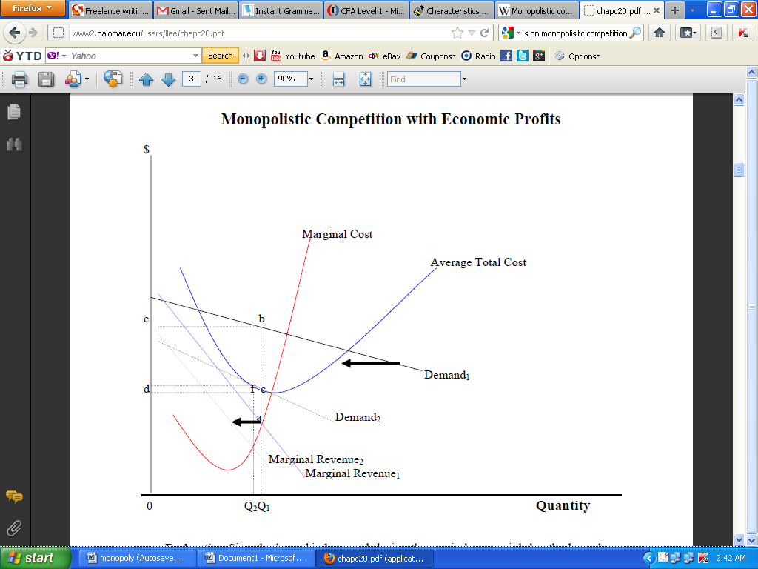
(Adopted from palomar 2012)
This diagram shows how in the short term a monopolistic competing firm is able to make lump-some profits.
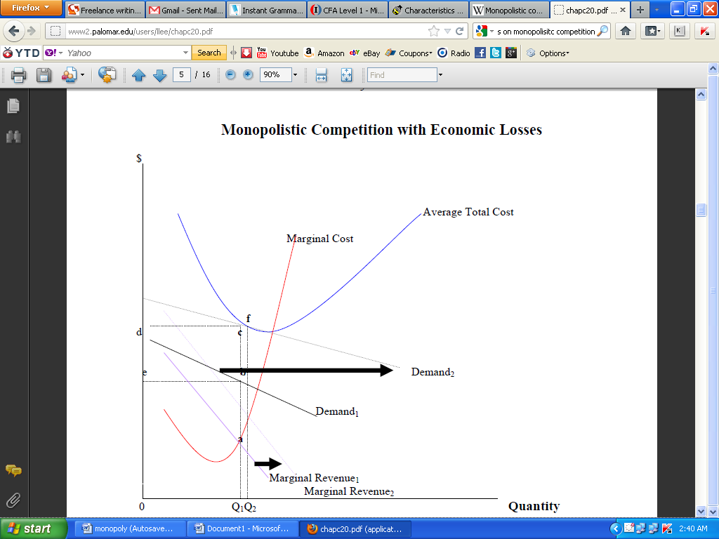
(Adopted from palomar 2012)
This diagram shows how in the long run the firms experience the shifted demand curve and the subsequent losses.

Reference List
Davies, A & Cline, T 2005. ‘A consumer behavior approach to modeling monopolistic
competition’, Journal of Economic Psychology, vol. 26, no. 6, pp. 797–826.
Palomar 2012, How to study for chapter 20 monopolistic competition, viewed 24 February
2012, <http://www2.palomar.edu/users/llee/chapc20.pdf>.

